2015-01-2344

Light-weight Liquid-Applied Sound Damping Material for Automotive Industry
Dr. Murteza Erman, Henkel Corporation
Copyright © 2015 SAE International
Abstract
In today’s world, automotive manufacturers are required to decrease CO₂ emissions and increase the fuel economy while assuring driver comfort and safety. To achieve desired acoustic performance targets, automotive manufacturers use various Noise-Vibration-Harshness (NVH) materials which they apply to the vehicle Body-In-White structures either in the body or paint shop.
Beside the sound deadening coatings applied onto the underbody of vehicles, they have historically used either constrained or free-layer sheets. The majority of these damping pads/sheets, so called asphalt sheets, are applied onto the floor pan inside the vehicle. These pre-manufactured and vehicle specific die-cut sheets are typically highly metal-carbonate, sulfate or silicate filled asphalt systems with a high specific gravity. Depending on the size of vehicle, the amount of these sheets can reach application weights of 10~20 kg/vehicle.
This paper will document the technical path that Dr. H. Oberst¹ laid with his fundamentals for free layer damping from bending vibration studies and how application of the Oberst equation has led Henkel to develop 1st, 2nd and 3rd generation Liquid-Applied Sound Damping materials (LASD) using the parameters in the equation with the goal to achieve better NVH management and lower weight per vehicle.
Introduction
Since the early 1990’s, automotive manufacturers have introduced LASD materials to replace asphalt sheets. The first generation of LASDs were highly filled systems with high specific gravity which emulated the asphalt sheets performance, but were robotically applied, rather than manually, as in the case for asphalt sheets. The primary motivation for automotive manufacturers to use LASD materials was the simple economics of less application labor and lower/less complex damping material inventory levels. Additional manufacturing efficiencies were achieved with a flexibility to manage NVH performance with programmable LASD robotic spray equipment across any number of vehicle architectures in assembly plants.
Asphalt sheets and LASDs are used to damp the structure-borne noise in 100~1000 Hz frequency range. Waterborne acrylic LASDs have become the material of choice due to their NVH performance, environmental advantage, and cost. Depending on each automotive manufacturer’s requirements for NVH temperature range, various acrylic emulsions with appropriate glass transition temperature may be chosen. The glass transition temperature of the polymer dictates the NVH performance of the final LASD²
The first commercial LASD, 1st generation LASD, were effective for vibration damping management but contributed higher than desired mass to the vehicle once processed. As automotive manufacturers searched for ways to reduce weight in their vehicles, material suppliers continued to innovate lower density LASDs without sacrificing the NVH performance. The next generations of LASD materials have reduced applied weights to 5~8 kg/vehicle with the same or better damping performance than 1st generation LASDs.
The 1st generation waterborne acrylic LASDs are highly filled systems with specific gravity between 1.6 ~ 1.9 g/cm³. Due to regulatory demands for fewer emissions and greater fuel economy, new targets to reduce weight of LASDs have been accelerated by automotive manufacturers. These new targets led to the development of 2nd generation spray-able waterborne acrylic based high damping LASD coatings with low specific gravity: 1.4~1.6 g/cm³, to reduce the weight/vehicle.
Further development of 3rd generation LASD technology has resulted from innovative approaches to the common understanding of damping (reducing the amplitudes and energy dissipation of load floor vibration) together with acoustic modelling of NVH hot spots, resulting in efficient and effective damping solutions.
When it comes to free layer damping, the loss factor η is given by Dr. H. Oberst equation 1 ^{1,3}
$η≐A \frac{E2}{E1} {\left(\frac{H2}{H1}\right)}^{2}η2$ (1)
A: Constant
E₁: Young’s storage modulus of substrate
E₂: Young’s storage modulus of LASD
H₁: Thickness of substrate
H₂: Thickness of LASD
η: Loss factor
η₂: Loss factor of LASD
The LASD’s damping properties are directly proportional to the Young’s modulus ratio, to the square of the thickness ratio of LASD to substrate and the viscoelasticity of the LASD. To increase the loss factor to maximum at a given substrate type and thickness we need to increase the LASD’s Young’s modulus, thickness and viscoelasticity.
The 1st generation LASD vibration damping performance was a function of mass and stiffness of the coating. To improve the damping further, a thicker LASD layer had to be applied. This was counter to the automotive manufacturers’ goal to reduce weight. Another problem was the surface cracking due to high Young’s modulus and rapid water evaporation while the LASD baked in the paint shop oven. This type of LASD was designed for micro-cracks to allow the water to evaporate during bake without creating a film separation effect similar to that of “pita bread”, (sometimes called “pitaing”) i.e. uncontrolled and excessive expansion and subsequent peel off.
To eliminate this issue the 2nd generation LASD was designed with controlled expansion in paint shop ovens. This expansion assured higher LASD thickness after bake and improved surface appearance without any cracking⁴. To reduce the final weight/vehicle the specific gravity of LASD was also reduced.
Figure 1 shows for 2nd generation LASD the composite loss factor at 40ºC versus thickness change ratio.
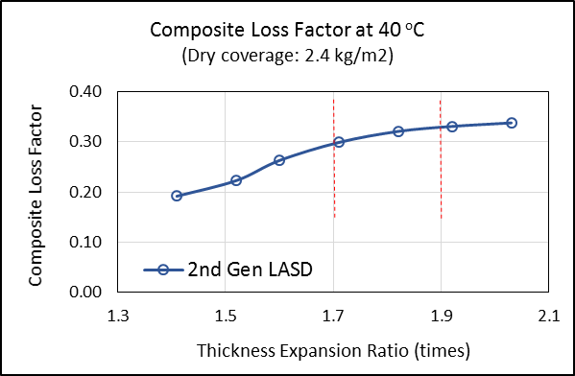
Figure 1. 2nd generation LASD, composite loss factor at 40ºC and 200 Hz versus thickness expansion ratio at 2.4 kg/m² coverage.

Increasing the expansion agent in LASD provided materials with increasing thickness expansion ratio range. Figure 1 shows the optimum thickness expansion ratio range as 1.7 ~ 1.9 times where composite loss factor reaches maximum. Thickness expansion ratio higher than 1.9 times did not yield more damping but could demonstrate increased propensity for peel off of LASD layer from substrate.
To improve the NVH performance further, developers used special acrylic latexes for the 3rd generation LASD. The polymer in emulsion was designed to provide increased interaction with acoustic fillers. Such increased interaction especially with platy (Mica) and fibrous (Wollastonite) fillers improved the energy dissipation by using the fillers as micro-constrained layers. While fillers in the 1st and 2nd generation LASD were used for cost reasons, fillers in the 3rd generation LASD can be seen as NVH active fillers. These fillers combined with the designed polymer macro-molecule in special latex improved the viscoelasticity of the LASD and maximized the NVH performance. Reducing the specific gravity of the LASD assured that automotive manufacturer’s targets regarding high NVH and less weight/vehicle could be met.

Table 1: Physical properties of LASD
 | 1st generation LASD | 2nd generation LASD | 3rd generation LASD
Wet Specific Gravity | 1.65 ~ 1.80 | 1.50 ~ 1.60 | 1.10 ~ 1.20
Expansion Ratio (times) | 0.9 ~ 1.3 | 1.7 ~ 1.9 | 1.7 ~ 1.9
Solid Content (%) | > 80 | > 77 | > 73
Bake performance | No pita/  slight crack | No pita/  No crack | No pita/  No crack
Introduced to OEM | 2005-Ford | 2007-Honda | 2014-Nissan

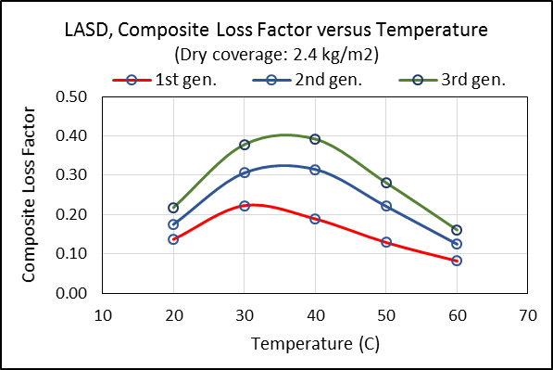
Figure 2. LASD, composite loss factor versus temperature at 200 Hz and 2.4 kg/m² coverage.
Figure 2 shows composite loss factor results for all LASDs at 200 Hz and 2.4 kg/m² coverage tested with center point (Japanese Standard: JIS G 0602⁵) damping testing.
The center point damping test is well acknowledged by Japanese OEMs to test LASD NVH performance and this method correlates well with the Oberst test method⁶.
It can be seen that the composite loss factor at the same dry coverage increases from 1st generation LASD to 3rd generation LASD. This also means that by using either the 2nd generation or 3rd generation LASD instead of 1st generation LASD the composite loss factor can be the same or better by using less dry coverage, i.e. lower weight/vehicle.
One of the challenges with water based acrylic LASD is the propensity for pita (uncontrolled and excessive expansion) and surface cracking due to water evaporation. Figure 3 shows all LASDs after bake. As it can be seen the LASDs do not pita and only 1st generation LASD shows slight tendency for cracking. This was achieved by optimizing the type, spherical, platy and fibrous fillers, and amount of the fillers in LASD.

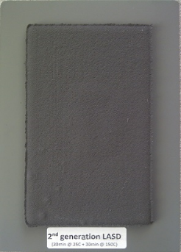
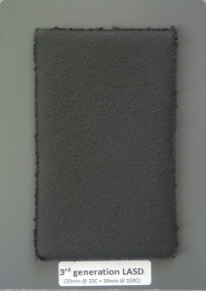

Figure 3. Baked 1st, 2nd and 3rd generation LASDs

Another concern from the Automotive OEM side is that application has a big impact on final NVH and there is doubt regarding NVH test result correlation between hand drawn bars and pump spray applied material in an actual assembly line. For that reason 3rd generation LASD was applied using airless pump and slit nozzle and impedance bars prepared for center point damping testing.

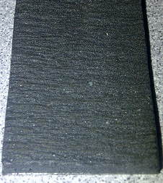
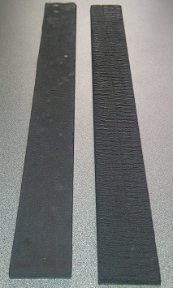

Figure 4. Hand drawn (far left), and pump applied (middle and far right picture) impedance bars.

Figure 4 shows hand drawn (left) and pump spray (middle, right) applied impedance bars. The far right picture shows the slightly wavy surface appearance when pump applied. When measured with laser displacement method the average difference between convexities and concavities was 0.5 mm after bake. The average final dry thickness on impedance bar was 3.5 mm.

The bake performance of the 2nd generation LASD after pump application confirms the hand drawn bake performance, i.e. LASD bakes/cures solid without any pitaing or cracking.

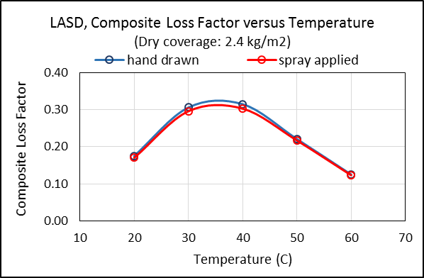

Figure 5. 2nd generation LASD, loss coefficient versus temperature of hand drawn and pump applied bars at 200 Hz and 2.4 kg/m² dry coverage.

This evaluation confirms that we can achieve similar NVH performance as long the application provides a smooth surface appearance. In our spray trial and using a slit nozzle we were able to achieve an almost uniform surface with an average difference between convexities and concavities of 0.5 mm. Such unevenness still provided loss coefficient results close to the hand drawn bar.

Table 2 below shows test piece dimensions and sample cure/bake parameters used to prepare test pieces for center point damping test.

Table 2: Test Parameters
NVH Test Method | Center Point Test Method, JIS G 0602
Substrate material | Steel
Substrate dimensions (mm) | 300 * 30 * 0.8
Dry LASD coverage (kg/m2) | 2.4
Ambient flash cycle | 20 minutes @ 25C
Bake cycle | Two times for 25 minutes @ 140C

Conclusion
Material suppliers have achieved automotive manufacturers’ quest to improve NVH and reduce weight/vehicle by creating generations of LASDs with lower specific gravity and increased thickness due to controlled expansion and improved viscoelasticity of the coating. Using the fundamental equation for free layer systems they have used different parameters to create the next generation LASD.
The innovative changes in the 3rd generation LASD material have transformed the technology from a mass dependent vibration damping material to a flexible and efficient NVH tool for acoustic and interior engineers. The ability to convert the kinetic energy into thermal energy as it is transmitted across vehicle load floors, roofs, and closures adds tremendous value and NVH utility to 3rd generation LASD material.
- 1st generation LASD: NVH relies mainly on weight and Young’s modulus ratio of the LASD to substrate (E₂/E₁).
- 2nd generation LASD: NVH relies mainly on thickness expansion ratio of the LASD to substrate (H₂/H₁).
- 3rd generation LASD: NVH relies mainly on thickness expansion ratio of the LASD to substrate (H₂/H₁) combined with improved viscoelasticity of LASD (η₂) based on increased polymer-filler interaction.

Also attention placed to application system and parameters is vital when material is applied at actual OEM lines. The goal of application should be to ensure a smooth surface after application and bake. A smooth surface close to hand drawn application will provide damping performance similar to lab tests and therefore maximum performance with a given LASD.

References
- Oberst, H., Akustische Beihefte, 1952, Heft4, 181~194
- Sperling, L.H., Sound and Vibration Damping with Polymers, ACS Symposium series, 1990, Chapter 1, 5~22
- Kerwin, E.M. and Ungar, E.F., Sound and Vibration Damping with Polymers, ACS Symposium series, 1990, Chapter 17, 317~345
- LeStarge, K., US Patent, 2005, US 6,872,761 B2
- Japanese Industrial Standard (JIS) G 0602, Test methods for vibration-damping property in laminated damping steel sheets of constrained type.
- SAE, 2009-01-2134, J.M. Dowling, P. Saha, A Correlation between Oberst Bar and Center Point Damping Results.

